The Children of Rebecca: A Lost Opportunity?
Rabbi Herzl Hefter
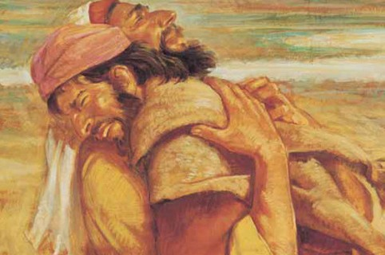
And Esau ran to meet him, and embraced him, and fell on his neck and kissed him, and they wept. (Bereishit 33:4)
For violence against your brother Yaakov,
Shame shall cover you, And you shall be cut off forever. (Ovadiah 1:10)
As opposed to the general positive impression delivered in Bereishit by the record of the brotherly reunion, the prophecy of Ovadiah fashioned the Jewish attitude toward Eisav and Edom in an overwhelmingly negative light. This has significance far beyond a theoretical attitude toward a long extinct people. Our sages identified Edom with Rome which was then extended to Christian Europe. To be sure, the Jewish people suffered immeasurably at the hands of the Europeans. This would seem to justify the attitude of the Sages towards Edom/ Rome and even elevate the teaching from an attitude to a prophecy. It is difficult to deny the uncanny prophetic nature of the following statement found in Tractate Megilah 6a-b
R. Isaac also said: What is meant by the verse, Grant not, O Lord, the desires of the wicked, draw
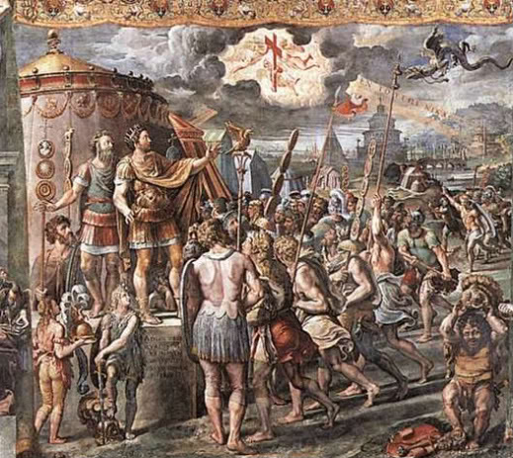
not out his bit, so that they exalt themselves, selah? Jacob said before the Holy One, blessed be
He: Sovereign of the Universe, grant not to Esau the wicked the desire of his heart, draw not out his bit: this refers to Germamia of Edom, for should they but go forth they would destroy the whole world.

We are all familiar with the famous statement by R. Shimon Bar Yohai, “It is a well-known fact [Halakha] that Eisav hates Yaakov.”(Sifrei Bamidbar 69)
But the relationship between brothers even if they are estranged is rarely simple.
James Carroll in his book, Constantine’s Sword, is plagued by the question, from the Christian perspective, “Could relations with the Jews have turned out differently?” Was the cross on Golgotha in effect the cross hairs of a rifle scope pointed irrevocably at Aushwitz? As a believing Christian with a deep sense of morality, this is a crucial question for him.
As Jews we need to ask an analogous question from our perspective. To be sure, Eisav is no Tzaddik; as a consequence of Yaakov’s underhanded acquisition of the blessings, Eisav awaits the death of his father and plots the murder of his brother. Nonetheless the question remains, do not statements of our Sages like those cited above, and their application to the real historical circumstances of the Roman Empire and the Christian heirs to that empire, act as a self-fulfilling prophecy poisoning the atmosphere even further?
I believe that the following Midrash addresses this problem.
And where was Dinah [when Yaakov presented his children to Eisav]? He[Yaakov] put her in a chest and locking her in, saying, ’This wicked man has an aspiring eye; let him not take her away from me.’ […] The Holy One blessed be He, said to him […] ‘You have withheld kindness from your neighbor; You would not give her in marriage to a circumcised person [Eisav]; lo! she is now married to an uncircumcised one[Shchem]. You would not give her in legitimate wedlock; lo! She was taken in illegitimate fashion’; thus it is written, And Dinah the daughter of Leah went out… (Bereishit Rabbah 76:9)
The Sages severely criticize Yaakov for withholding his daughter Dinah from Eisav. Perhaps she would have been successful in tempering his passions and make an honest man out of him, so to speak.
What are the sages getting at with this Midrash? What role would Eisav have filled as Yaakov’s son-in-law? As a senior member of Yaakov’s tribe, the brother/son-in-law (or uncle/brother-in-law to the other brothers) Eisav’s strengths and virtues, his physical prowess and powers of persuasion (ztayid be fiv) could have been put in the service of the fulfillment of the historical mission of the Jewish People – bringing the knowledge of the God of Israel to the world; a God of history who cares passionately about righteousness and justice. Eisav would have been the thirteenth tribe. For our sages to imagine Eisav this way, identifying him with Rome as they did, excites our imagination. What would have been if Rome, rather than converting to Christianity as a consequence of Constantine’s vision on the Milvian Bridge, had become Jewish instead? The Sages of the midrash are trying to imagine the might of the Roman Empire as an instrument of bringing the Torah to the world.
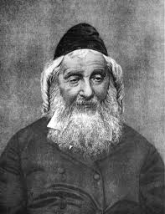
And it is here that the Sages are courageously self-critical. Yaakov, they understood, squandered the opportunity to draw Eisav in. Would the effort have been successful? We will never know. But Yaakov is held accountable for not at least trying. Yaakov lost faith in his brother and perhaps lacked the self-confidence to make the attempt.
So, is there no hope for a more constructive and even loving sibling relationship in the future? R. Naftali Zvi Yehuda Berlin, the rosh yeshiva of Volozhin, thought that there was when he wrote,
”And they cried: They both cried. This comes to teach us that Yaakov’s love for his brother was awakened at that moment and he loved Eisav. So it is in future generations when the descendants of Eisav are awakened by a pure spirit and they recognize the qualities of the seed of Israel, then we too awaken to recognize Eisav because he is our brother…” (Haemek Davar Bereishit 33:4)

